COMP 4311 Programming Languages
Homework 1

1) (5pts) If we want to define a Regular Expression (RE) for a token, the token is called identifier. The identifier must start with a letter (l) and end with a letter(l), it can be any number of letters (l) of digits (d) in the middle. Show the (a) RE for this token (b) NFA diagram that results from applying the construction to the regular expression, and (c) applying the transformation illustrated by Example 2.14 from textbook to create an equivalent DFA
ANS:
a) l(l|d)*l
b) and c) see slides
2) (5pts) Consider the following grammar:
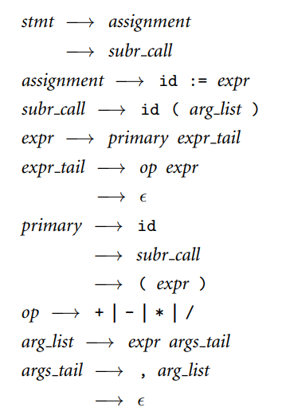
(a) List all the terminals and non-terminals; (b) Construct a parse tree from stmt for the input string res := func(a, b) + c, which res, func, a, b, c are ids; c) if we have stmt for the input string: res := + a, is it a valid stmt? Draw the parser tree to explain.
Ans: a) Terminal: id, :=, (, ), e,+, -, *, /. Nonterminal: remaining things like primary, op and etc…
Hints: anything only appear on the right is terminal, anything appear on the right is non-terminal.
b) see pic.
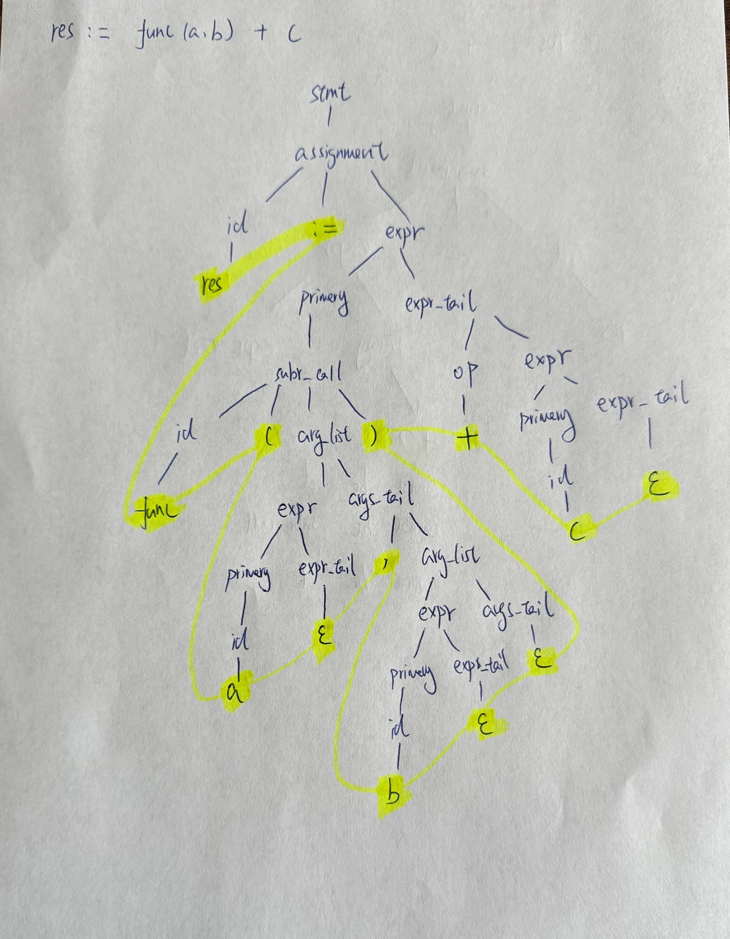

c) it is not a valid statement, because we cannot construct a parse tree. See the primary part under expr.


